**Data Structures Lab Report 3**

Group members: Vivek Kunapareddy, Yuan Cheng

1. The concepts explored in this lab assignment were:
   1. Class design: This lab involved constructor creation and constructor overloading. This is an important principle in object oriented programming and hence will be extremely useful when transitioning into the workforce of software engineering
   2. The other concept explored in this lab was operator overloading. This involved overloading regular arithmetic operators in C++ to accept the objects created using our created class. This will also help when transition in to the workforce as it a fundamental concept of class design and is used widely in every codebase
2. The initial design of the class involved setting all the private member variables to the type double. However this was changed to manage constructor overloading. As constructors are differentiated by the parameter list passed to them, we could not have all the member variables declared as double. Hence we changed the angle and the magnitude of the vector to be int initially. While implementing Task 3 however due to multiple problems cropping up and due to rounding errors in the angle and magnitude, we decided to switch them back to double and switch over the co-ordinates to integer values. By doing so we restricted the range of our vectors but made our program consistent. While doing so we realised that it is better to plan class design on paper beforehand as switching between data types involves a lot of effort in an already implemented class. Planning it out beforehand allows us to avoid redundant effort and gives us a blueprint to work off of.

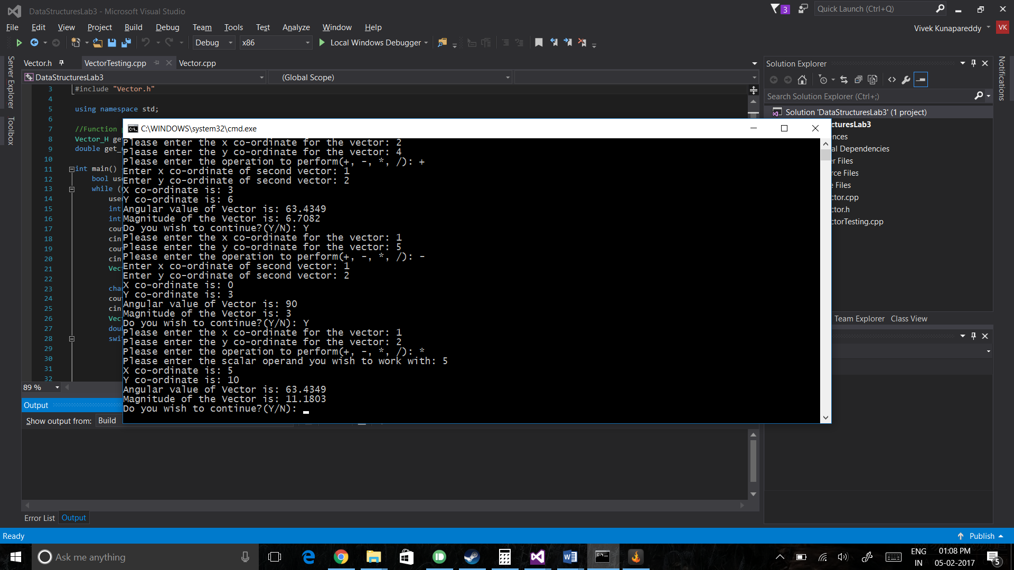

First three operations represented

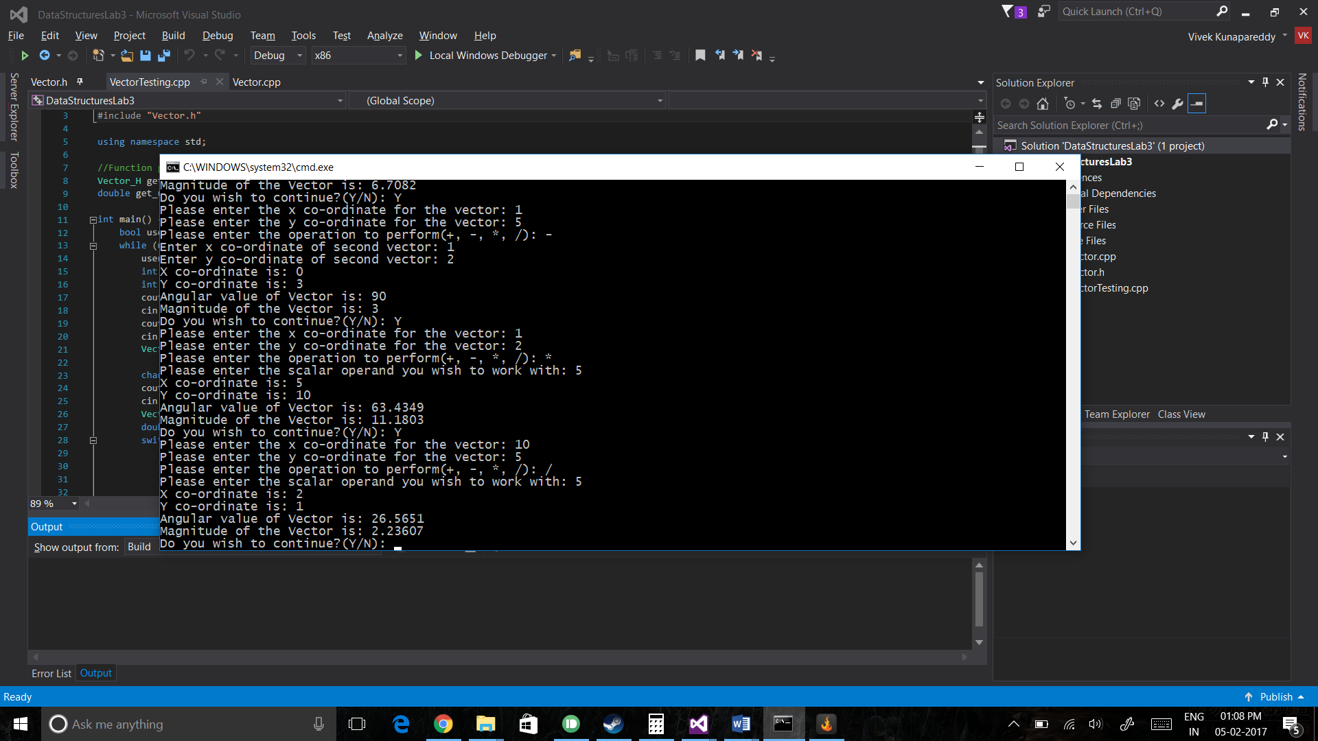

Division represented

**Special instructions to compile and run**:

When asked to enter co-ordinate values, please enter only integer values

When asked to choose an operation, please enter only the arithmetic sign of the operation you wish to use

When using * and / operations the second input should only be a scalar integer value

**Group contribution:**

The entire lab was done during the lab period together as a group.

All design decisions and design changes were made together